Population Assignment

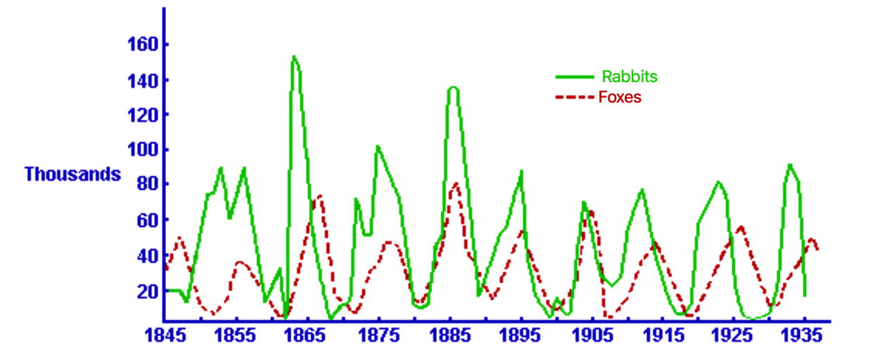

1. In the year 1885, what is the population of the fox?
- 80
- 140
- 80,000
- 140,000

2. In the year 1875, what is the rabbit population?

3. What factor may be responsible for the unusual rabbit population of 1865?

- Lack of available food
- Increase in fox population
- Decrease in fox population

4. Draw a conclusion on what would happen to the population of the rabbits if the foxes were hunted more for their furs.

- There would be no change
- The rabbit population would increase
- The rabbit population would decrease

Explain your answer below. Why?

5. Look at the years 1890 through 1935, the population of rabbits go through cycles of increasing and decreasing. What seems to happen to the fox population?

6. Why do the fox populations seem to cycle (increase) shortly after the rabbit cycle?

7. What is the rabbit population at the end of 1935?

